LAB 1

Murtaza ali qazi(2112120)

DEVOPS

Szabist Karachi

Task1

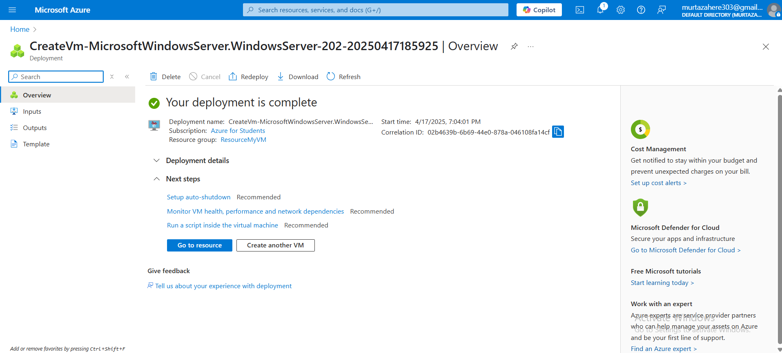

Task2



Task 3

